Herramientas para la defensa y Apoyo de las Personas Amparadas con la Acción Diferida para los que Ingresaron en la Infancia (DACA)
La amenaza de una probable cancelación del programa Acción Diferida para los que Ingresaron en la Infancia (DACA), está generando muchas preguntas y temor. Es importante mencionar que el programa puede continuar funcionando, aun así, el Presidente decidiera no hacer nada al respecto. Eso ha generado la estrategia del Fiscal General de Texas para liderar una ofensiva que busca ejercer presión al Presidente para que lo cancele. Ante tal incertidumbre hemos creado la siguiente lista de recursos, la es una compilación de mensajes, puntos de discurso, información para personas directamente afectadas, ejemplos de acciones, y una guía para escribir artículos de opinión en apoyo a los esfuerzos de defensa Todas estas herramientas han sido desarrolladas por organizaciones aliadas a nivel local y nacional entre ellas FLIC, CAP, UWD, NILC, OFA, Define American, Immigrant Legal Resource Center, FWD.us y la encuesta desarrollada por Prof. Wong de UCSD. Les invitamos a revisarlos y a utilizarlos en sus esfuerzos de defensa de DACA, a la vez le invitamos a compartir las herramientas diseñadas para informar, educar y movilizar a la comunidad afectada, tales como las desarrolladas por FLIC (ver adjuntas) y ILRC (vinculo abajo indicado)
OJO: Antes de tomar acción para defender a DACA es importante informarnos sobre que es el programa, como funciona, quienes se benefician, cuales son los criterios para calificar al alivio y cuál es la historia de DACA; para ello le invitamos a leer el sitio del Servicio de Ciudadanía e Inmigración de los Estados Unidos (USCIS) en inglés y español.
Todas las herramientas están listas para ser utilizadas inmediatamente y para continuar utilizando luego del anuncio que haga la administración sobre el futuro de las 800,00 personas amparadas bajo DACA. Las páginas 3 y 4 incluyen graficas que reflejan los impactos positivos del programa.
LISTADO DE RECURSOS
What Do I Need to Know if the DACA Program Ends? (August 28, 2017) – Diseñada por ILRC
Wellness and Mental Health Resource Guide – Diseñada por UWD
EJEMPLOS DE TWEETS
- El estudio más grande de los beneficiarios de DACA muestra pq son vitales para la economíahttps://www.americanprogress.org/?p=437956 #Defend DACA [INSERT DACASHARABLE1]
- ¡Ahora es el momento de continuar– no terminar– DACA! https://www.americanprogress.org/?p=437956@UNITEDWEDREAM @nilc @CAPimmigration @TomWongPhD #defendDACA [INSERT DACASHARABLE1]
- El salario promedio por hora aumentó en un 69% después de recibir DACA— lo q se traduce en más ingresos.https://www.americanprogress.org/?p=437956 #DefendDACA [INSERT DACASHARABLE1]
- El 16% de los beneficiarios de DACA compró su primera vivienda; 5% Inició su propio negocio.https://www.americanprogress.org/?p=437956 #DefendDACA [INSERT DACASHARABLE1]
- NUEVO: al menos el 72% de las 25 principales empresas de Fortune 500 emplean a los beneficiarios de DACAhttps://www.americanprogress.org/?p=437956 #DefendDACA [INSERT DACASHARABLE2]
- Graficas para los mensajes arriba indicados, disponibles aqui https://drive.google.com/drive/folders/0BzwKcEUflSONRG1nUDlQaDZjNjA
GRAFICAS POR ESTADO
Facebook: https://drive.google.com/drive/folders/0B-hcpTpsyWGQRDhuYXZlR2ZoS2M?usp=sharing
Twitter: https://drive.google.com/open?id=0B-hcpTpsyWGQcFo4SExEMWp6bzQ
GRAFICAS A NIVEL NACIONAL
Twitter https://lh3.googleusercontent.com/-y-tT8vwKEo0/WaBcdKM0QEI/AAAAAAAADW8/IMUjVN30sXUuZ2FE0NmAIpVs1gvcOyIXACL0BGAYYCw/h560/dada_tw.png
Facebook https://lh3.googleusercontent.com/-UVvHr5dxc1Y/WaBcWxiflzI/AAAAAAAADWw/5AXufLMQ8qAbrXHjjfEqKepJ8t1VK1-QwCL0BGAYYCw/h788/daca_fb%2B%25281%2529.png
MAS EJEMPLOS DSE TWEETS
1. SAMPLE TWEETS TARGETED at MOCs - We've put together a list of easy click-to-tweets targeted at a number of members of Congress. Please consider tweeting out today and tomorrow.
2. GRAPHICS - A number of graphics that can be used for your social media purposes.
3. We Are With DREAMers: bit.ly/WithDreamers - Now more than ever it's important to recruit elected, civic, business, and faith leaders to add their name to the letter.
4. NEW DACA SURVEY Folks at CAP sent around a new survey from UWD, NILC, CAP and Prof. Wong a UCSD. Please help lift up (graphics are located in the graphics folder above):
- Largest survey of recipients shows why DACA is critical to the economy https://www.americanprogress.org/?p=437956@UNITEDWEDREAM @nilc @amprog @TomWongPhD [INSERT DACASHARABLE1]
- Now is the time to #DefendDACA not end it! https://www.americanprogress.org/?p=437956@UNITEDWEDREAM @nilc @CAPimmigration @TomWongPhD [INSERT DACASHARABLE1]
- Average hourly wages rose by 69% after DACA— that means more tax revenue for cities, states, and the U.S.https://www.americanprogress.org/?p=437956 #DefendDACA [INSERT DACASHARABLE1]
- 16% of DACA recipients bought houses; 5% started businesses https://www.americanprogress.org/?p=437956#DefendDACA [INSERT DACASHARABLE1]
- NEW: At least 72% of the top 25 Fortune 500 companies employ DACA beneficiaries https://www.americanprogress.org/?p=437956 #DefendDACA [INSERT DACASHARABLE2]
5. OP/ED GUIDANCE - FWD.us has put together a guide to authoring, pitching and other helpful tips for DACA op/eds.
6. LIST OF INFLUENCERS TO Retweet
https://twitter.com/JuanSaaa/status/901870532789972993 (an open letter from Juan Escalante)
https://twitter.com/dianeguerrero__/status/901155446693572608
https://twitter.com/AmericaFerrera/status/901164516741750784
https://twitter.com/TheDemocrats/status/901111750485049345
https://twitter.com/TomPerez/status/900903697097555968
https://twitter.com/TomPerez/status/900903854031687682
https://www.facebook.com/democrats/photos/a.413933741942.188832.12301006942/10155254625621943/?type=3&theater
https://twitter.com/MichaelSkolnik/status/900862700670115840
https://twitter.com/MichaelSkolnik/status/900865065779384325
https://twitter.com/MichaelSkolnik/status/900865612645314560
https://twitter.com/Amy_Siskind/status/900845484759298048
https://twitter.com/igorvolsky/status/900854892801273856
https://twitter.com/RepJeffDenham/status/900833319314747393
https://twitter.com/shanvav/status/900845633132744704
https://twitter.com/NYCMayor/status/900866315421921280
https://twitter.com/igorvolsky/status/900863749225156608
https://twitter.com/deray/status/900845034186125313
https://twitter.com/julissaarce/status/900868208999018496
https://twitter.com/JoshDorner/status/900866925252792320
https://twitter.com/GovInslee/status/900859751872856065
https://twitter.com/MoveOn/status/901084502658863104

Everything You Need To Know About DACA
President Donald Trump is considering putting an end to the Deferred Action for Childhood Arrivals (DACA) program. DACA is a successful program with strong, bipartisan support that has helped nearly a million immigrants obtain work permits, and strengthened our country. Download the fact sheet HERE.

Popular Program Could Soon End Hurting Country
- DACA Could Be Gone In less Than Ten Days: Ten state attorneys general have threatened to file a lawsuit over the program on September 5th if the executive branch does not rescind the program.
- Unlikely The Government Will Defend DACA: It is unclear how the executive branch will respond to this lawsuit if it is filed. However a recent article noted that “the Trump administration doesn't believe it has the legal authority to maintain the current program.”
- Ending This Program Would Affect Everyone: This program does not just protect the best and the brightest undocumented immigrants (though they are included), it protects everyday people and revoking it will have dire consequences for many local communities across America.
- Get Smart: We wanted to make sure that you had all of the most pertinent information about this program, as well as stories from recipients of this endangered executive action:

What is DACA?

- Deferred Action for Childhood Arrivals, or DACA, is a Department of Homeland Security policy that allows for certain undocumented Americans to have their deportations delayed, and obtain a temporary work permit.
- To be eligible, a person must have Were under the age of 31 as of June 15, 2012, came to the United States before reaching your 16th birthday, have continuously resided in the United States since June 15, 2007, up to the present time, enrolled in or graduated from school, and not have a felony conviction. For additional qualifications, visit the official USCIS website.
- Individuals must submit to a biometrics and background check, and pay $495 in fees as part of their application. DACA lasts for two years, and each renewal (which costs an additional $495) is not guaranteed.

Stories from DACA Recipients. Visit our story platform at DefineAmerican.com/stories for real perspectives from people with DACA. And please watch the following below:

DACA Is Popular With Trump Voters (and most Americans)
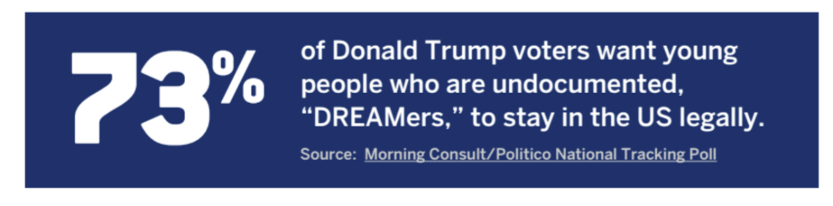
What DACA Students Can and Cannot Do
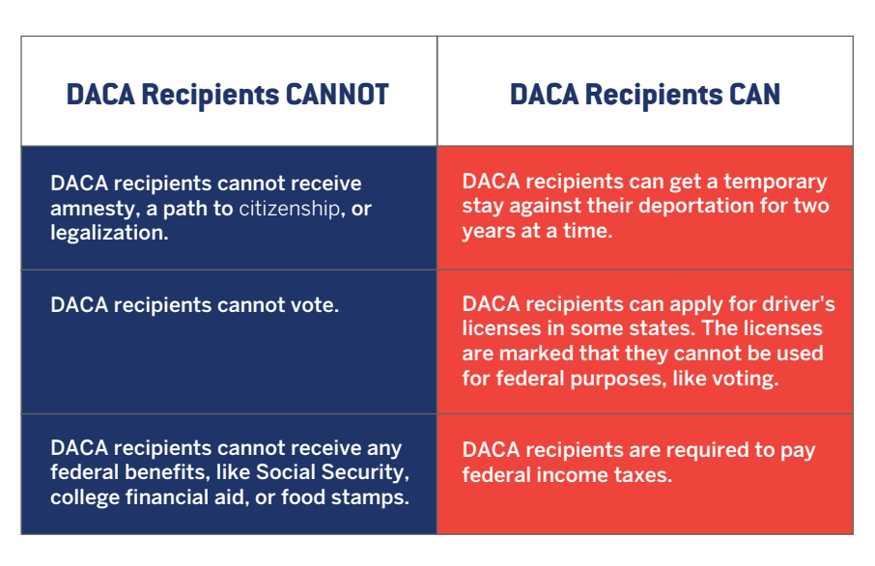

DACA Helps America by Contributing 1.2 Billion in New Tax Revenue
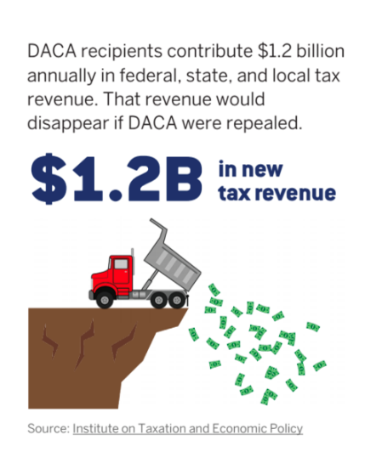

DACA Has Helped Recipients Better Contribute To America
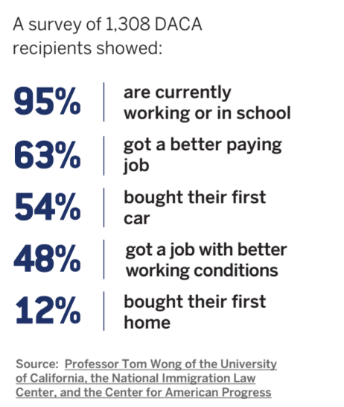

DACA Has Been Successful

